**Experiment 5**

**Lab Book:**

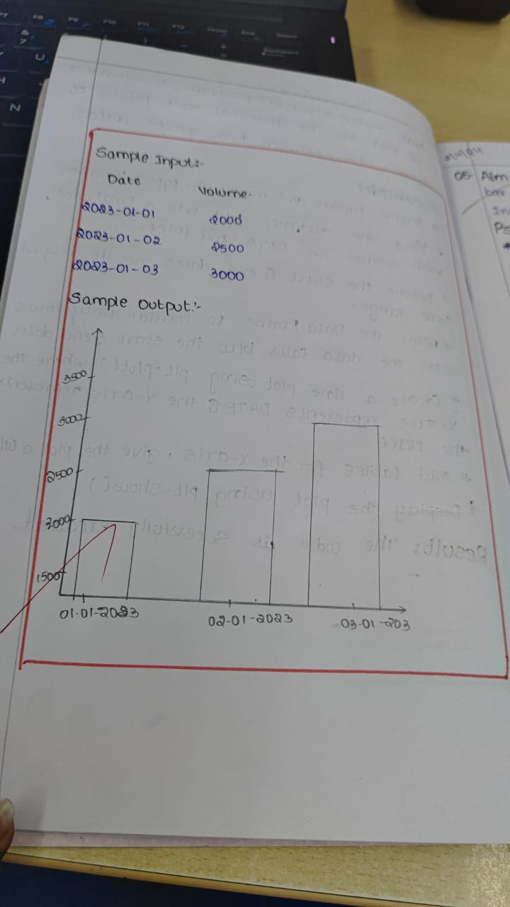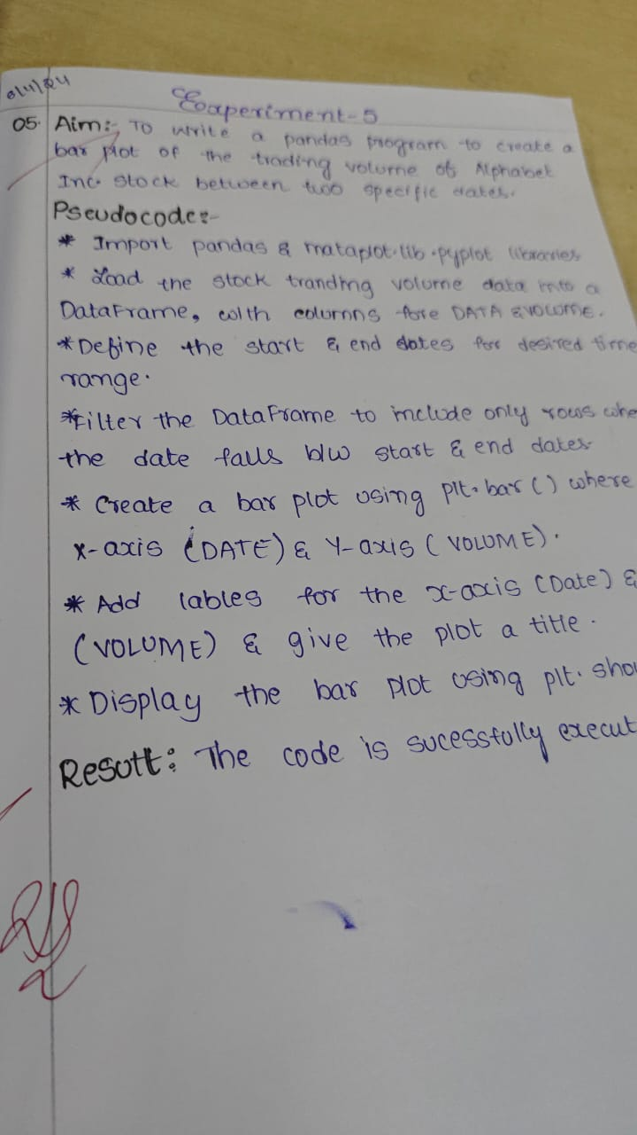

**Code:**

import pandas as pd

import matplotlib.pyplot as plt

import yfinance as yf

data = yf.download('GOOGL', start='2023-01-01', end='2023-10-01')

sample_data = data[['Volume']].head(6)

sample_data.plot(kind='bar', title="Alphabet Inc. Trading Volume", xlabel='Date', ylabel='Volume', figsize=(10,6))

plt.show()

**Sample Output**

